Standard 3 Quiz Name:_________________________ Period:___ Date: ______________
Algebra 2: Mr. Allison
Standard 3: Absolute value and compound inequalities.

SOLVE each of the following inequalities AND graph the solution set. Show all work!

- $\left|x\right|+7≤14$ 2) $\left|5-2x\right|≥9$

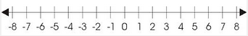

- $6-2 \left| 5x+3\right|>-12$

SOLVE and GRAPH each of the following inequalities. Show all work!
- $3x-8≤-23$ or $7-2x<3$ 5) $-13<6x+5≤29$

